**Bauhaus Omnibus entry**

**Summary**

In 1919 a young architect named Walter Gropius initiated one of the most modern art schools of the twentieth century in the city of Weimar in Thuringia, Germany. He called it the Bauhaus. Its unusual name can be translated as building hut” indicating its connection with the medieval tradition of cathedral building and the idea of a total work of art.

The Bauhaus is not only famous for its ideas or its buildings in Weimar and Dessau, but also for its members, among them the three directors of the school – the architects Walter Gropius (1919-1928), Hannes Meyer (1928-1930), and Mies van der Rohe (1930-1932). Renowned modern artists taught there like Lyonel Feininger, Vassily Kandinsky, Paul Klee, László and Lucia Moholy-Nagy, Herbert Bayer, Marcel Breuer, Wilhelm Wagenfeld, Anni und Josef Albers, Oskar Schlemmer, Marianne Brandt or Gunta Stölzl. All of them endorsed modernism at a time when modern art and abstraction was far from being accepted – contemporaries understood it first of all to be a post-war rebellion similar to the then notorious Dada movement. The overall aim of the Bauhaus was to redefine fundaments of composition and construction as well as the use of colours.

**Bauhaus Design (1919-1933)**

**By Anja Baumhoff**

In 1919 a young architect named Walter Gropius initiated one of the most modern art schools of the twentieth century in the city of Weimar in Thuringia, Germany. He called it the Bauhaus. Its unusual name can be translated as ‘building hut’ indicating its connection with the medieval tradition of cathedral building and the idea of a total work of art. In its early days the school was still very much influenced by Expressionism and teachers were called *master* instead of professor. Many of the Bauhaus ideas, however, were less original than they may seem and have already been developed before the First World War.

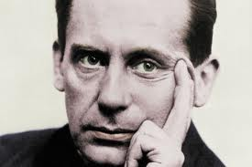 Walter Gropius

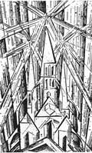 Cover of the Bauhaus Manifesto of 1919 symbolizing the building of the future with a woodcut from Lyonel Feininger.

An important part of the Bauhaus’ contribution the modernism were its publications, the so-called *Bauhausbücher,* a series of fourteen books, and the Bauhaus journal. Members of the school also helped to develop the *Deutsche Industrie Norm* (DIN) in order to standardize buildings and furniture and thus pave the way for mass production. But the Bauhaus is not only famous for its ideas or its buildings in Weimar and Dessau. Its is also known for its members, among them the three directors of the school – the architects Walter Gropius (1919-1928), Hannes Meyer (1928-1930), and Mies van der Rohe (1930-1932). Renowned modern artists taught there like Lyonel Feininger, Vassily Kandinsky, Paul Klee, László and Lucia Moholy-Nagy, Herbert Bayer, Marcel Breuer, Wilhelm Wagenfeld, Anni und Josef Albers, Oskar Schlemmer, Marianne Brandt or Gunta Stölzl. All of them endorsed modernism at a time when modern art and abstraction was far from being accepted – contemporaries understood it first of all to be a post-war rebellion similar to the then notorious Dada movement. The overall aim of the Bauhaus was to redefine fundaments of composition and construction as well as the use of colours.

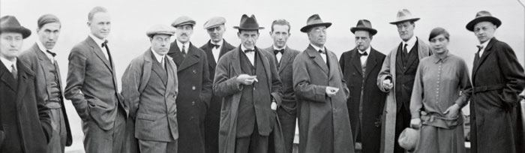

Masters on the roof of the Bauhaus building in Dessau. From left to right: Albers, Scheper, Muche, Moholy-Nagy, Bayer, Schmidt, Gropius, Breuer, Kandinsky, Klee, Feiniger, Stölzl, Schlemmer, BHA

The early Bauhaus sought to combine the teaching of art as well as design and in order to achieve this the former fine arts academy merged with the old school for applied art in Weimar. This way Gropius hoped to secure the education of a new type of artist beyond all the usual academic specialization. In order to further art education the school developed new teaching methods like the preliminary course which owes its existence to the artist Johannes Itten. In addition, workshops were set up as the base for any art was to be found in handcraft. In order to remove any distinction between fine arts and applied arts artists and craftsmen lead the workshops together.

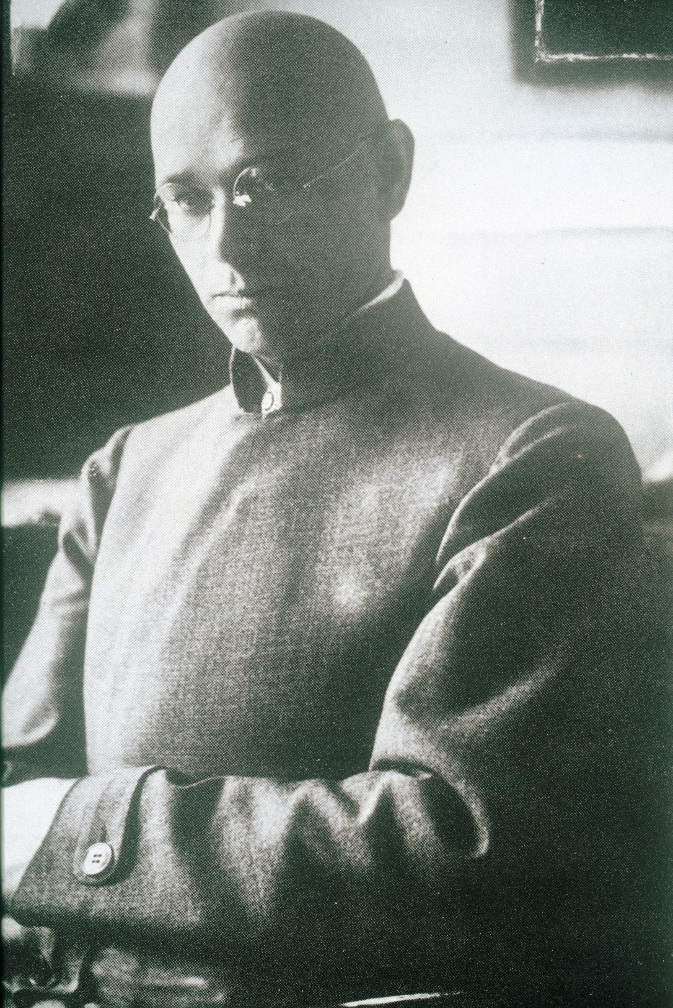 Johannes Itten at the Bauhaus in Weimar

Emerging out of its Expressionist phase the school changed direction in 1923, and embarked on the idea of ‘art and technology - a new unity’. The Bauhaus workshops now started to produce prototypes for industry which where functional and showed a modern aesthetic. Wanting to unite all the arts and crafts into a total work of art under the leadership of architecture, they intended not only to produce new forms but to create a new world. A settlement was planned but did not materialize out of lack of funds. Nevertheless, a start was made and for the 1923 exhibition the *Haus am Horn* was erected, which was a model house designed by the painter Georg Muche. It ignited further discussion because of its radical design, its flat roof and white walls.

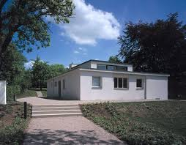 Haus am Horn in Weimar today (Internet)

The exhibition of 1923 is one of the highlights of the Bauhaus’ legacy although its reception among contemporaries was rather mixed. The exhibition came about because the Weimar Bauhaus was state-funded and its radical ambitions provoked so much opposition in Germany that it now had to justify its activities. Walter Gropius hoped that the big exhibition of 1923 would finally calm his critics – but far from it. The fact that the Bauhaus wanted to bring about a new style of life expressed in a new style of living that needed a new kind of interior design was seen as foreign, non-German even and simply alien and cold. Bauhaus modernism clashed largely with the dominant contemporary taste which was characterized by eclecticism, cheap neo classicist decoration and velvety drapes surrounded by opulent furniture commonly identified as a bourgeois style of life. Thus the school was too advanced for its time.

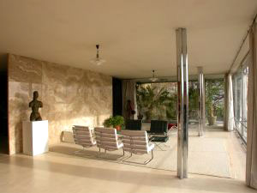 Mies van der Rohe, Villa Tugendhat.

Someone who helped to stir the Bauhaus ship into the modernist direction was the Hungarian constructivist Lászlo Mohol-Nagy who joined the school in 1923 when Johannes Itten left. The Dutch artist and writer, Theo van Doesburg, founder of the Dutch De Stijl group, also strongly influenced the Bauhaus after 1921 and propagated radical modernism.

The new slogan ‘art and technology a new unity’ in combination with Louis Sullivan’s motto ‘form follows function’, the reduction of design to minimalist forms combined with a black and white interior as well as with simple basic colours characterized the Bauhaus legacy. That said, the Bauhaus was more than a reductionist design of basic geometric forms and colours, flat roofs or a polished interior.

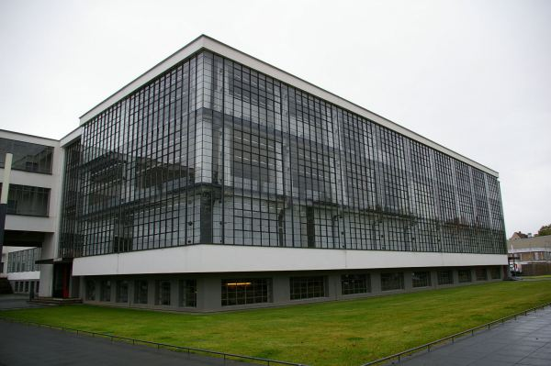

The Bauhaus building in Dessau today

When Walter Gropius left the Dessau institute in 1928, he was succeeded by the Swiss architect Hannes Meyer who had a more radical approach and reformed the school’s program in order to promote more socially responsible architecture and design. Meyer wanted the Bauhaus to help improve the living conditions of the poor, raise hygienic standards and build affordable houses. He captured this in the slogan ‘Volksbedarf statt Luxusbedarf’ – to build for the masses and not produce luxury goods for the few. During his brief time as director the Bauhaus workshops focused even more on industry and mass production. He set up the first architectural class in 1927 and a workshop for photography in 1929.

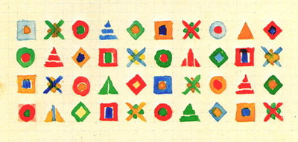

Weaving design by Gunta Stölzl

Other workshops in Dessau were typography and advertisement, carpentry, metal, weaving, wall painting, sculpture, and the stage workshop. The more arts and crafts oriented workshops like pottery and bookbinding did not make the move to Dessau where Gropius had constructed the now famous Bauhaus building and several houses for the masters. His successor, Hannes Meyer, lost his position after only two years to Mies van der Rohe who took over as director in 1930. Again right wing political forces had won. Van der Rohe changed the course of the school one more time and tried to focus more strongly on architecture. But even though he managed to calm the schools intense political climate in order to satisfy Bauhaus’ critics he could not prevent the National Socialists from closing it down. In Berlin, the Bauhaus existed only for a few months and that did not leave him enough time or money to reestablish the school anew.

The Bauhaus encompassed about 1250 members during its time and always had a male-dominated image. But the institution was made up of roughly one third of female students. Most women worked in the weaving workshop, few in the pottery workshop or the bookbinding workshop. There were exceptions, including Marianne Brandt, who today is one of the most celebrated members of the metal workshop. Despite the rather conventional gender stereotypes present at the Bauhaus and within the modern movement, in general, many courageous female artists left their mark during that time.

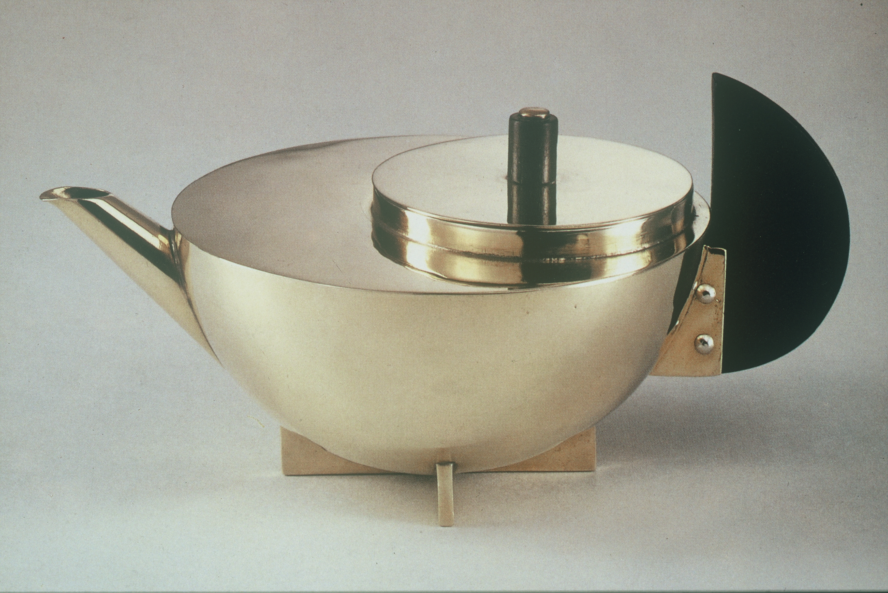 Tee pot by Marianne Brandt

**References and further reading**

Magdalena Dr. and P. Gossel, Eds. (2005) *Bauhaus*, Taschen America LLC.

Baumhoff, A. (2001) *The Gendered World of the Bauhaus. The Politics of Power at the Weimar Republic's Premier Art Institute, 1919-1931.* Peter Lang, Frankfurt, New York.

Sharp, D. (1991) *The Illustrated Encyclopedia of Architects and Architecture*, New York: Quatro Publishing.

Wingler, H. M. (1986) *The Bauhaus. Weimar, Dessau, Berlin, Chicago*. MIT Press.

Wick, R. K. (2000) *Teaching at the Bauhaus*. Hatje Cantz.

**Bauhaus: Dance and Movement**

**By Susan Funkenstein**

Dance and movement were central to the Bauhaus’ institutional and vernacular history. There, students, faculty, and guests experienced dance through modernist theatrical settings, movement exercises, and social dancing, all of which conveyed Bauhaus aesthetic ideas and fostered community. Similar to other Bauhaus explorations, dance forms transitioned in aesthetics and ideals from Expressionism to Constructivism.

The Theater Workshop (founded Summer 1921) served as dance’s institutional home. Lothar Schreyer, its first Master of Form (1921-23), advocated for an Expressionist, mystical, and spiritual theatre but less for dance. Dance became more vital in the workshop under Schreyer’s successor, Oskar Schlemmer (1923-29). His most famous choreography, the *Triadic Ballet* (*Das Triadische Ballett*, 1922-32), was a humorous, abstract, and modern take on ballet costumes and movements, but the large costumes hindered the dancers’ movements and evoked war-torn bodies. Broken into three acts, most versions of the choreography featured a ‘gay burlesque’ classical ballet act in yellow, a ‘ceremonious and solemn’ character dancing act in pink, and a ‘mystical fantasy’ abstract act in black.[1]

Schlemmer’s ideals of Bauhaus concert dance are evident in his *Bauhaus Dances* (*Die Bauhaustänze,* 1926-29), a series of brief Constructivist-leaning works. These non-narrative, non-allegorical choreographies explored dancers’ movements across the stage’s axes. Performers utilized industrial materials and abstract shapes (with metal sheets, blocks, poles, and hoops) within those geometric confines, whereas primary colours complemented the colour theory teachings in the Preliminary Course. Bulky, padded costumes abstracted dancers’ bodies and evoked marionettes, dolls, and automata. After Schlemmer’s departure, the Theatre Workshop was dissolved.

Movement and dance also thrived separately from the Theatre Workshop. Gertrud Grunow offered lessons on harmony (1920-24). Aligned with Johannes Itten, Grunow investigated how elements such as sound, form, and colour physically and psychically affected the individual, such that internal experiences could turn into outward expression through rhythmic dance. In contrast to Grunow’s spiritual teachings, Karla Grosch taught women’s gymnastics (1928-32) along Constructivist lines, combining athleticism with the geometric arrangement of human form. Activities in her courses included throwing medicine balls, gymnastics, and yoga, often executed out-of-doors or on the Bauhaus-Dessau roof. Grosch’s mentor Gret Palucca, a modernist dancer recognized for her high springs and optimistic dance style, guest performed at the Bauhaus in 1925 and 1927 and befriended many artists. An example of the Bauhaus’ interdisciplinarity, Wassily Kandinsky’s ‘Dance Curves’ essay and drawings explore the geometry underlying Palucca’s movements, whereas the students engaged with her modernity and celebrity through photographs and typographic experiments.[2]

Central to the school’s celebratory atmosphere was social dancing. Annual theme and costume parties included the White Festival (Das Weiße Fest,1926), the Beard, Nose, and Heart Festival (Das Bart-Nasen-Herzensfest, 1928), and the Metallic Festival (Das Metallische Fest, 1929). Organized by Theatre Workshop students supervised by Schlemmer, the festivals transformed the Bauhaus buildings with elaborate decorations and attendees danced to music from the Bauhaus Band. Dance steps were a mix of jazz dance such as the shimmy and Charleston with folk dancing. Frequent parties throughout the year, whether off-site student parties or birthday celebrations, also featured impromptu social dancing.

Located in the former East Germany, the Dessau Bauhaus was restored in 1976 and served as a cultural and design center until the Fall of the Wall. Since 1994 the Bauhaus Foundation has regularly programmed experimental theatre, dance, and music in the restored space, as well as reconstructed theatre and dance works first staged there in the 1920s.

**Selected Works**

By Lothar Schreyer

*Mankind (Mann,* 1920*)*

*Moon Play (Mondspiel,* 1923)

By Ludwig Hirschfeld-Mack

*Crossroads (Kreuzspiel*, 1923)

By Kurt Schmidt

*Mechanical Ballet (Das Mechanische Ballett*, 1923)

By Oskar Schlemmer

*Triadic Ballet (Das Triadische Ballett*, preliminary performance 1916, first full performance 1922, revised 1923, 1926, 1932)

*Bauhaus Dances (Die Bauhaustänze)* (1926-29). Examples include:

* *Block Play (Baukastenspiel)*
* *Figure in Space (Kunstfigur)*
* *Flats Dance (Kulissentanz)*
* *Form Dance (Formentanz)*
* *Gesture Dance (Gestentanz)*
* *Glass Dance (Glastanz)*
* *Hoop Dance (Reifentanz)*
* *Metal Dance (Metalltanz)*
* *Pole Dance (Stäbetanz)*
* *Space Dance (Raumtanz)*

**References and further reading**

Bergdoll, B., and Dickerman, L. (2009) *Bauhaus 1919-1933: Workshops for Modernity*. New York: Museum of Modern Art.

Blume, T. and B. Duhm, eds. (2008) *Bauhaus Buhne Dessau/Bauhaus Theatre Dessau*, Berlin: Jovis. Includes dvd of performances 1985-2007.

Fiedler, J., and Feierabend, P., eds. (2000) *Bauhaus*. Cologne: Könemann.

Funkenstein, S. (2012). ‘Picturing Palucca at the Bauhaus,’ *New German Dance Studies*, eds. S. Manning and L. Ruprecht, Urbana: University of Illinois Press, 45-62.

---------- (2007) ‘Engendering Abstraction: Wassily Kandinsky, Gret Palucca, and “Dance Curves,”’ *Modernism/Modernity* 14 (3): 389-406.

Koss, J. (2006) ‘The Bauhaus Theater of Human Dolls,’ in *Bauhaus Culture: From Weimar to Cold War,* ed. K. James-Chakraborty, Minneapolis: University of Minnesota Press, 90-114.

Maur, K. (1979) *Oskar Schlemmer,* Munich: Prestel Verlag.

Scheper, D. (1988) *Oskar Schlemmer. Das Triadische Ballett und die Bauhausbühne* Berlin: Akademie der Künste.

Schlemmer, O. ([1969] 1971) *Man: Teaching Notes from the Bauhaus*, ed. H. Kuchling, trans. J. Seligman, Cambridge: MIT Press.

Schlemmer, T., ed. ([1958] 1972) *The Letters and Diaries of Oskar Schlemmer.* Trans K. Winston, Middletown: Wesleyan University Press.

Schlemmer, O., L. Moholy-Nagy and F. Molnár. ([1925] 1961) *The Theater of the Bauhaus*, ed. W. Gropius, trans. A.S. Wensinger, Middletown: Wesleyan University Press.

Trimingham, M. (2011) *The Theatre of the Bauhaus: The Modern and Postmodern Stage of Oskar Schlemmer*, New York: Routledge.

**Film Documentation**

Edition Bauhaus (2013) *Bühne und Tanz/Stage and Dance/Ludwig Hirschfeld-Mack, Wassily Kandinsky, Kurt Schmidt, Lothar Schreyer,* absolut Medien.

Edition Bauhaus (2014) *Bühne und Tanz/Stage and Dance/Oskar Schlemmer*, absolut Medien.

McCall, D. and R. Leacock (1986) *Bauhaus Dances.* See ordering and supplementary material at www.bauhausdances.org

**Suggested Paratexts**

Schlemmer’s costume designs for the *Triadic Ballet* (1926 version)

<http://www.harvardartmuseums.org/art/304377>

T. Lux Feininger, photograph of *Metal Dance*, 1928-9:

<http://www.getty.edu/art/collection/objects/34701/t-lux-feininger-metalltanz-american-about-1928-1929/>

**Notes**

1. O. Schlemmer, ‘Man and Art Figure,’ in O. Schlemmer, L. Moholy-Nagy and F. Molnár. ([1925] 1961) *The Theater of the Bauhaus*, ed. W. Gropius, trans. A.S. Wensinger, Middletown: Wesleyan University Press, 34.
2. S. Funkenstein (2012), ‘Picturing Palucca at the Bauhaus,’ *New German Dance Studies*, eds. S. Manning and L. Ruprecht, Urbana: University of Illinois Press, 45-62; S. Funkenstein, (September 2007), ‘Engendering Abstraction: Wassily Kandinsky, Gret Palucca, and “Dance Curves,”’ *Modernism/Modernity* 14:3, 389-406.